**Objective Questions**:

* **1) What is the total no. of tables present in the data?**

There is only one table in this data set if I consider the main sheet i.e Raw data.

But since excel has 2 sheets – and if we are referring to both sheets, then number of tables will be 2.

* **2) What is the total no. of attributes present in the data?**

Total number of attributes present in the data is 20.

As attribute also means column – hence 20 columns are available in this data.

* **3) How many categorical columns are there in the data?**

There are 18 categorical columns in this data – as categorical data refers to components that are finite and discreet.

Below is the column names considered as categorical:

RestaurantID, RestaurantName, CountryCode, City, Address, Locality, LocalityVerbose, Longitude, Latitude, Cuisines, Currency, Has Table booking, Has Online delivery, Is delivering now, Switch to order menu, Price range, Rating, Datekey-Opening

* **4) The data consists of some inconsistent and missing values so ensure that the data used for further analysis is cleaned.**

In column “Datekey_Opening” values “_” was replaced by “-“ to present the data in proper date format.

There were 9 cases in Cuisines column which were BLANKs. To avoid any misleading information, I have deleted these line items as they contributed only 0.001% of the entire dataset.

* **5) Using the LookUp functions, fill up the countries in the original data using the country code.**

*Answer / Sheet Reference*: The output is available in original data in column name U / “Country”

*Approach*: Country code and Country relationship details was shared in “Country Description” sheet.Hence applied Vlookup in reference to this sheet and added the countries in original data.

* **6) Create a table to represent the number of restaurants opened in each country**.

*Answer / Sheet Reference*: PFB snap for the answer and in workbook refer sheet name “Objective #6”

*Approach*: To get the output I have used Pivot table feature and in Rows mentioned countries and in Values I have extracted the count of restaurant.

*Insight*: India has the most number of restaurants when compared country-wise followed by USA.

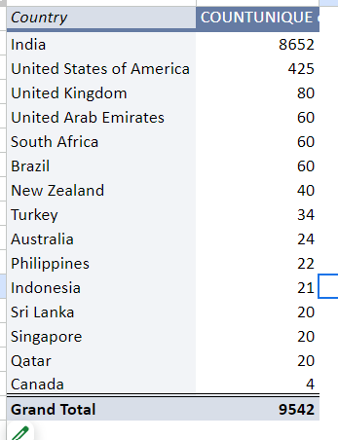

* **7) Also, the management wants to look at the number of restaurants opened each year, so provide them with something here.**

*Answer / Sheet Reference*: PFB snap for the answer and in workbook refer sheet name “Objective #7”

*Approach*: Firstly, Year column was created in Raw data, formula used to get the year is =YEAR(T2). To get the output I have used Pivot table feature and in Rows mentioned Years and in Values I have extracted the count of restaurant.

*Insight*: Most number of restaurants were opened in the year 2018. But every year the count of restaurants has been above 1000.

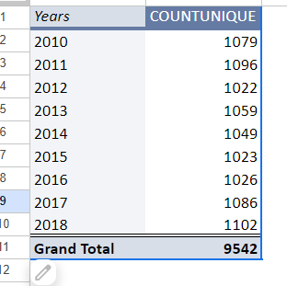

* **8) What is the total number of restaurants in India in the price range of 4?**

*Answer / Sheet Reference*: 388 restaurants are there in India with price range 4. PFB snap for the answer and in workbook refer sheet name “Objective #8”.

*Approach*: I have used Pivot table feature and in Rows mentioned Country and in Values I have extracted the count of restaurant and added Country and Price Range in Filter option to get the desired output.

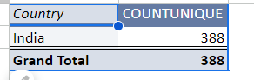

* **9) What is the average number of voters for the restaurants in each country according to the data?**

*Answer / Sheet Reference*: PFB snap for the answer and in workbook refer sheet name “Objective #9”

*Approach*: I have used Pivot table feature and in Rows mentioned Country and in Values I have extracted the votes and then from Value Field Setting selected Average function to display average votes.

*Insight*: Highest average votes are for Indonesia, followed by UAE.

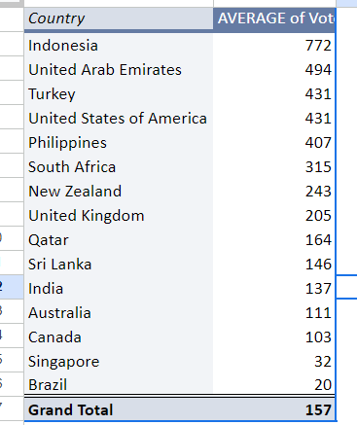

* **10) Calculate the average rating for all the restaurants that have price_range < 4 and provide online delivery. Use only the “IF” function, Logical Operators, and Aggregation functions to solve this problem. [Note: Don’t use Conditional aggregation in this question.]**

*Answer / Sheet Reference*: Answer is 3.27381151 and in workbook refer sheet name “Objective #10”

*Approach*: I created a helper column “Conditional Avg.” and used the formula =IF(AND(P2<4,M2="Yes"),S2,"-") to determine if a restaurant meets the criteria.

Later I used the formula : =AVERAGE('Raw Data'!W:W), this formula calculates the average of the values in helper column “Conditional Avg.”, which are the ratings of the restaurants that meet the criteria.

* **11) Using Conditional formatting highlight the rows of restaurants that are located in the countries or cities that you’ve suggested to the management for opening new restaurants.**

*Answer / Sheet Reference*:  - Highlighted in yellow colour in the original data are the restaurants which falls in this condition.

*Suggestion*: As per my suggestion – restaurants with greater than 4 rating and having online delivery are the area where we should be focusing on opening new restaurants as these are the locations where monopoly is playing most of the roles.

Pivot understanding for the filters suggested above – according to which only 2 countries fall in this condition India and UAE and city count is 17 whereas restaurant count is 91.

*Approach*:Used Conditional Formatting to select and under custom formula applied =AND($S:$S>=4,$M:$M="Yes") which highlights the restaurant who fulfil both my suggested conditions.

* **12) Create a new customized price column that consists of the abbreviation/symbol of the currency along with the Average_cost_for_two value. [Use string operations to do this task]**

*Answer / Sheet Reference*: Added additional column X and used the concatenate and mid function to perform this operation. Formula used is as follows:

=CONCATENATE(MID(K2,FIND("(",K2)+1,FIND(")",K2) - FIND("(",K2)-1)," ",R2)

* **13) How can you create an array formula in Excel or Google Sheets to count the number of restaurants listed that do not offer online delivery, are in the lowest price range, and have an average cost for two people less than or equal to 250 Indian Rupees? (common currency)**

*Answer / Sheet Reference*: 1691, added in GSheet with sheet name “Objective #13:”

*Approach*:Converted all the currency to INR to keep a common currency for this I plotted conversion rate against each currency in the raw file and then to find the answer used below formula.

=COUNTIFS('Raw Data'!M:M,"No",'Raw Data'!P:P,"=1",'Raw Data'!Z:Z,"<=250")

**Subjective Questions**:

* **1) Suggest a few countries where the team can open newer restaurants with lesser competition. Which visualization/technique will you use here to justify the suggestions?**

*Answer / Sheet Reference*: PFB chat for the answer and in workbook refer sheet name “Subjective #1”

*Approach*: Used Pivot to plot the country wise restaurant count wherein Rating is >=4 and count of restaurant is <=20

*Insight*: Below are the 6 countries wherein we can open newer restaurants: Australia, Canada, Indonesia, Qatar, Singapore & Sri Lanka.

*Suggestion:* I have suggested this filter because these are the countries wherein high rated restaurants are very less and if we focus on providing good service then we can disrupt the market.

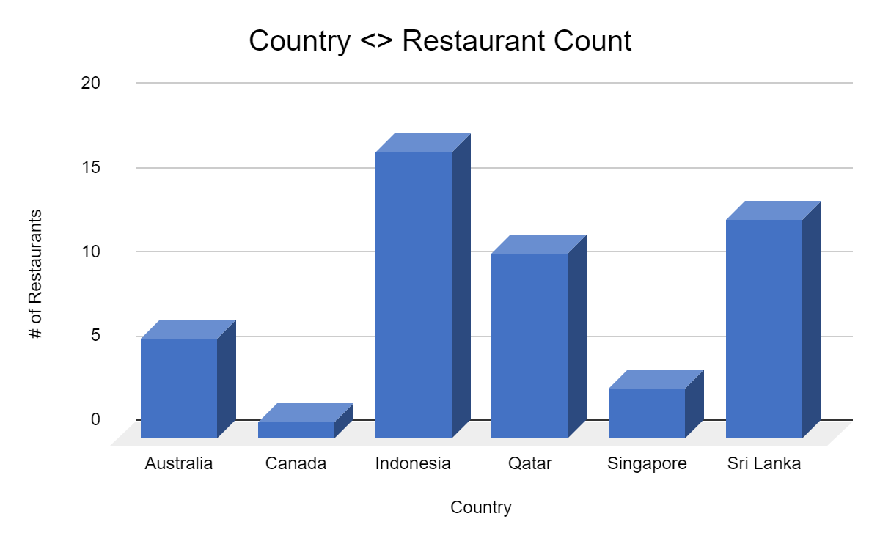

* **2) Come up with the names of States and cities in the suggested countries suitable for opening restaurants.**

*Answer / Sheet Reference*: PFB snap for the City in the suggested countries for opening restaurants & workbook refer sheet name “Subjective #2”

*Approach*: Used Pivot to plot the country & city wise restaurant count wherein Rating is >=4. Added Country fiter to show the output for only the suggested countries.

*Insight*: Below are the 14 cities wherein we can open newer restaurants, all from my suggested countries

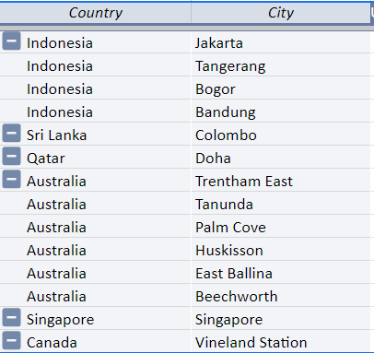

* **3) According to the countries you suggested, what is the current quality regarding ratings for restaurants that are open there?**

*Answer / Sheet Reference*: PFB snap for the answer and in workbook refer sheet name “Subjective #3”

*Approach*: Used Pivot to plot the country in row and Rating in Values and used field setting to display Average of rating. Used filter to select the suggested countries

*Insight*: All suggested countries are having average ratings above 3.5

*Recommendation:* Table Booking & Online Delivery is not needed as it won’t boost any rating and less expenditure means less rating – hence we will have to invest more than average to ensure high ratings

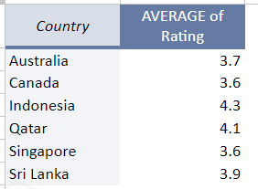

* **4) Also, what is the current expenditure on food in the suggested countries, so we can keep our financial expenditure in control?**

*Answer / Sheet Reference*: PFB 2nd snap for the answer and in workbook refer sheet name “Subjective #4”

*Approach*: Used Pivot to plot the country in row and Average cost of two with common currency i.e INR in Values and used field setting to display Average of rating. Used Filter to select the suggested countries

*Insight*: In Singapore the average cost is too high as compared to rest of the countries.

*Recommendation:*  We can invest in cuisines which are having high ratings and less expense – below snap lists the cuisines which can be recommended to open a budget restaurant with high rated cuisines both.

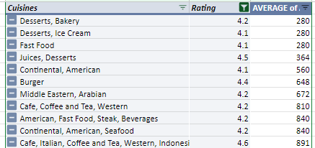

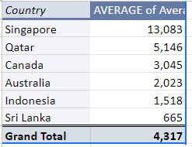

* **5) Come up with the names of restaurants from the recommended states that are our biggest competitors and also those that are rated in the lower brackets, i.e. 1-2 or 2-3.**

*Answer / Sheet Reference*: PFB snap for the answer & workbook refer sheet name “Subjective #5”

*Approach*: Used Pivot to plot the restaurant name wherein Rating is >=4.5. Added Country in filter to show the output for only the suggested countries.

*Insight*: There are 14 such restaurants with high ratings i.e >= 4.5 which will be our biggest competitors.

*Recommendation*: To make sure our newly added restaurants are fighting strongly against the biggest competitors we will have to invest in high rated cuisines with less expense and table booking and Online delivery options should not be activated.

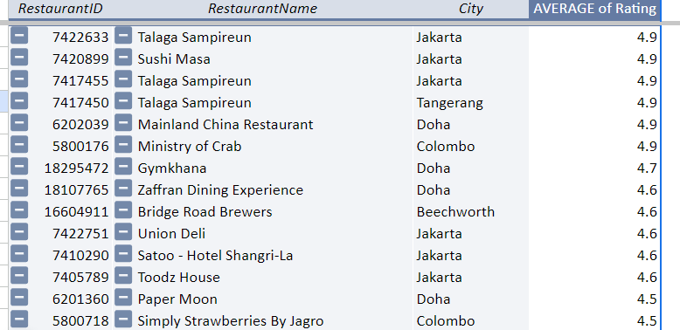

*Restaurants with rating 1-2:*

There are no restaurants within 1-2 rating.

*Restaurants with rating 2-3:*

Below is the list of restaurants with 2-3 ratings – under Pivot filter used between value condition to get the be;ow list.

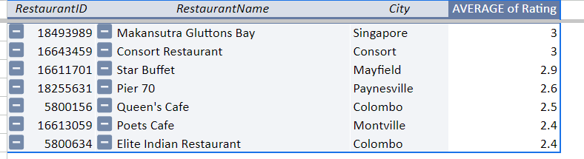

* **6) Which cuisines should we focus on in the newer restaurants to get better feedback? Does the choice of cuisines affect the restaurant ratings?**

*Answer / Sheet Reference*: PFB snap for the answer & workbook refer sheet name “Subjective #6”

*Approach*: Used Pivot to plot Restaurant Cuisine in rows and Avg. of ratings and Count of restaurants in values – then used conditional filter in Pivot to select Avg. rating >= 4 and restaurant count >=10

*Insight*: Below are the 7 cuisine which I would suggest to be focused in newer restaurants as they have been tested in more than 10 restaurants and feedback is also pretty good.

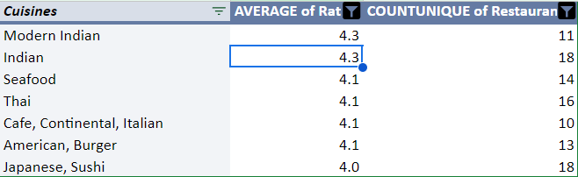

Further to answer the question does the choice of cuisine affect the restaurant ratings : It does, because cusines which are tested in more than 10 restaurants - there are only 7 cuisines who are having >= 4 ratings but there are 57 such cuisines who are having <=3 ratings.

In our data set one restaurant is one cuisine.

* **7) According to our current data, should we go for online delivery and table booking? Does that affect the customer’s ratings?**

*Answer / Sheet Reference*: PFB snap for the answer & workbook refer sheet name “Subjective #7”

*Approach*: Used 2 Pivots to plot Table Booking and Online Delivery in rows separately and restaurant ID in values – then used Pie chart to plot the % Contribution of YES and NO – used the filter in Pivot to show the readings for restaurants having >=4 ratings

*Insight*: There is no compulsion to have online delivery or table booking feature – as there is hardly 20% of restaurants having both the features and are falling under >=4 rating brackets. Most of the restaurants in this rating bracket is not having this feature

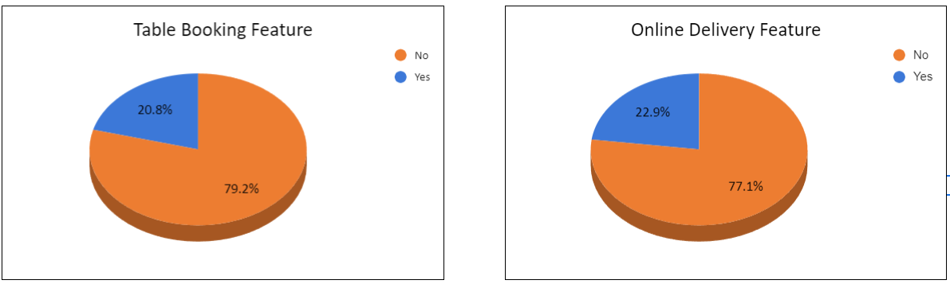

* **8) Should the team keep the rate of cuisines higher? Will that affect the feedback? According to our data are the rates of cuisines and ratings, correlated?**

*Answer / Sheet Reference*: PFB snap for the answer & workbook refer sheet name “Subjective #8”

*Approach*: Created Psuedo Ratings to avoid decimal segregation and then used Chart to show the rating vs rate comparison

*Insight*: The team should keep the rate of cuisines higher as ratings and rates are corelated. In below Chart its clear that high rates means high rating and vice-versa.

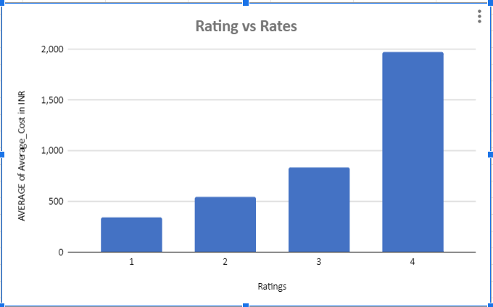

* **9) What is the distribution of the number of restaurants of different price ranges in all the countries?**

*Answer / Sheet Reference*: PFB snap for the answer & workbook refer sheet name “Subjective #9”

*Approach*: Created Pivot table – Price range in rows and Count of restaurants in Values. Plotted Pie chart based on this Pivot.

*Insight*: Price Range 1 distribution of restaurants is very high across all countries followed by price range 2

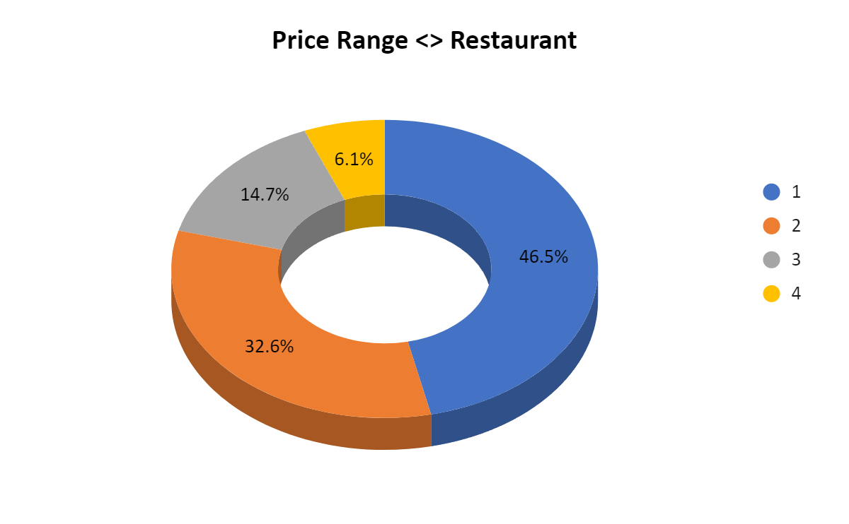

* **10) Explain your approach in brief for suggesting countries/cities in order to open new restaurants, if the objective and subjective questions would have not been given to assist you. [you have to give bullet pointers in order to answer this question]**
* My first preference would be the countries with few restaurants.
* Post this I would filter out those countries who has good rating (above 4).
* This particular filter will help me identify the set of cities where there are less competition and good quality customer.
* The only approach that I will have to do is ensure that my restaurant is having the top-rated cuisine and providing the best of services.
* And the business is then ours to take.